Weak 2 Red Teaming Task

This project demonstrates the implementation of a complete Security Information and Event Management (SIEM) lab using the Elastic Stack ecosystem. The environment was designed to simulate real-world SOC (Security Operations Center) workflows including log collection, threat detection, dashboard visualization, Sigma rule engineering, Filebeat telemetry ingestion, and alert-based threat hunting.
The lab integrates Elasticsearch, Kibana, and Filebeat to collect, process, index, and visualize system telemetry and simulated attack activity. Multiple attack scenarios such as failed SSH logins, Nmap reconnaissance scans, suspicious PowerShell execution, reverse shell behavior, malicious downloads, and privilege escalation attempts were generated and successfully detected inside Kibana.
The project also demonstrates:
- Detection engineering using Sigma rules
- Threat hunting workflows
- SIEM dashboard creation
- Filebeat log ingestion
- Kibana alert rule creation
- Security event visualization
- MITRE ATT&CK mapping

Objectives
The primary objectives of this project were:
- Build a functional SIEM environment using Elastic Stack
- Configure Elasticsearch and Kibana services
- Deploy Filebeat for telemetry collection
- Ingest Linux system and custom threat logs
- Simulate cyber attack activity
- Detect malicious behavior using Kibana queries
- Create Sigma detection rules
- Build SOC monitoring dashboards
- Implement alerting workflows
- Practice real-world threat hunting techniques

Technologies Used

Component | Purpose
Elasticsearch | Log indexing and search engine
Kibana | Visualization and threat hunting dashboard
Filebeat | Log collection and forwarding
Sigma Rules | Detection engineering framework
Linux (Kali) | Threat simulation environment
GitHub | Project version control and documentation
Syslog/Auth Logs | Telemetry sources

Environment Setup :

Operating System
- Kali Linux

Elastic Stack Components :
The following services were configured and validated:

Elasticsearch :
Responsibilities:
- Store indexed logs
- Process search queries
- Handle SIEM telemetry
Validation Steps:
- Service startup verification
- Cluster health verification
- Authentication configuration
- HTTPS communication enabled
Commands Used:
sudo systemctl start elasticsearch
sudo systemctl status elasticsearch
curl -k -u elastic https://localhost:9200

1. Install Required Tools
Install these tools in Kali Linux:

Tools List
- Git
- VS Code
- Elastic Security
- Security Onion (later)
- Wazuh
- CrowdSec
- Metasploit
- OpenVAS
- DefectDojo
- Velociraptor
- MITRE Caldera

2. Create Main Project Folder
mkdir cyart-red-teaming
cd cyart-red-teaming

3. Create Week 2 Folder Structure
Run: mkdir -p "Week 2"/{Documentation,Screenshots,Notes,Reports,Workflow}

4. Create README File
touch "Week 2/README.md"

5. Initialize Git Repository
git init

6. Verify Folder Structure
tree
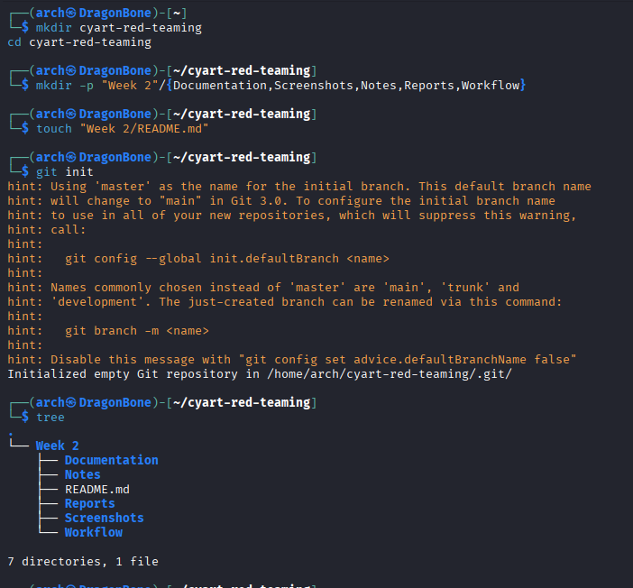

step 1
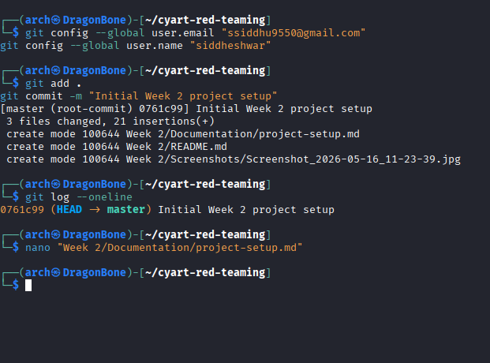

step 2

Project Setup Documentation

Objective
Created the initial project structure for CyArt Red Teaming Week 2 tasks.

Steps Performed
- Created GitHub project folder.
- Created Week 2 directory structure.
- Initialized Git repository.
- Verified folder structure using tree command.

Tools Used
- Kali Linux
- Git
- Terminal

Output
Project structure successfully created.

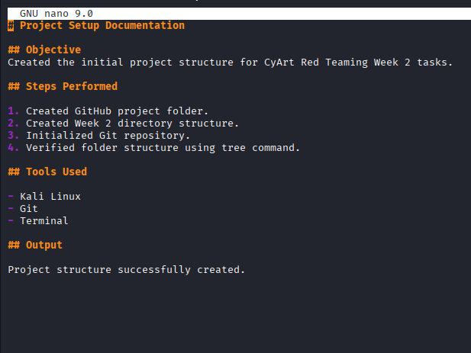

https://github.com/SidVela/cyart-red-teaming
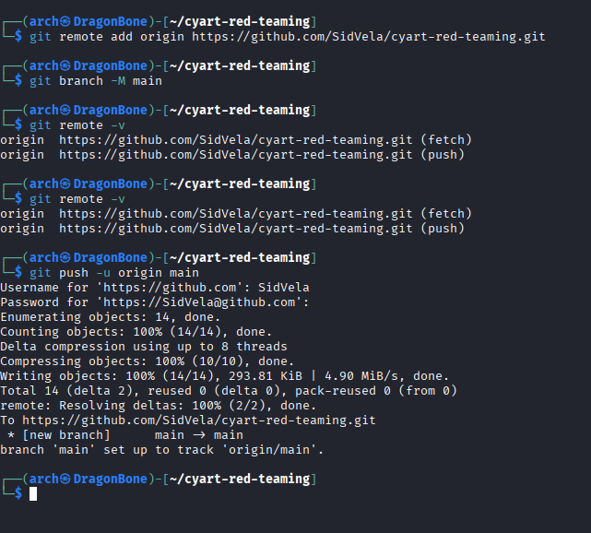

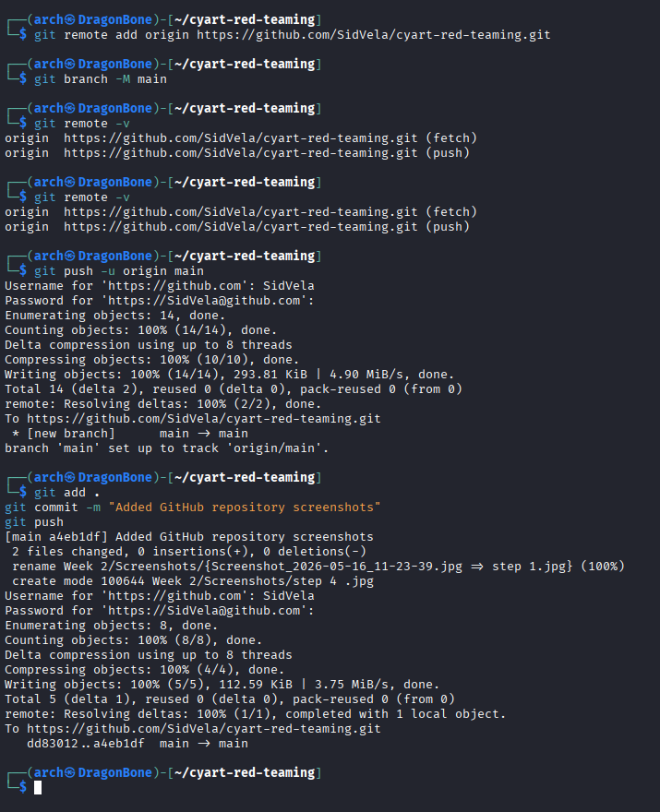

Update Kali Linux
sudo apt update && sudo apt upgrade -y
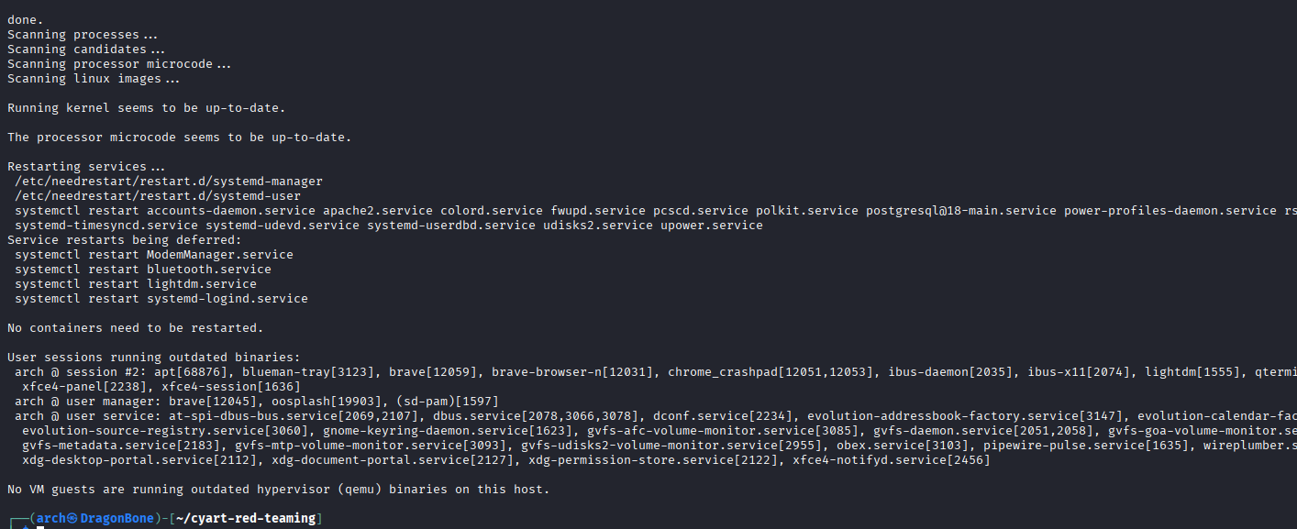

Install Dependencies
sudo apt install curl wget apt-transport-https gnupg unzip -y

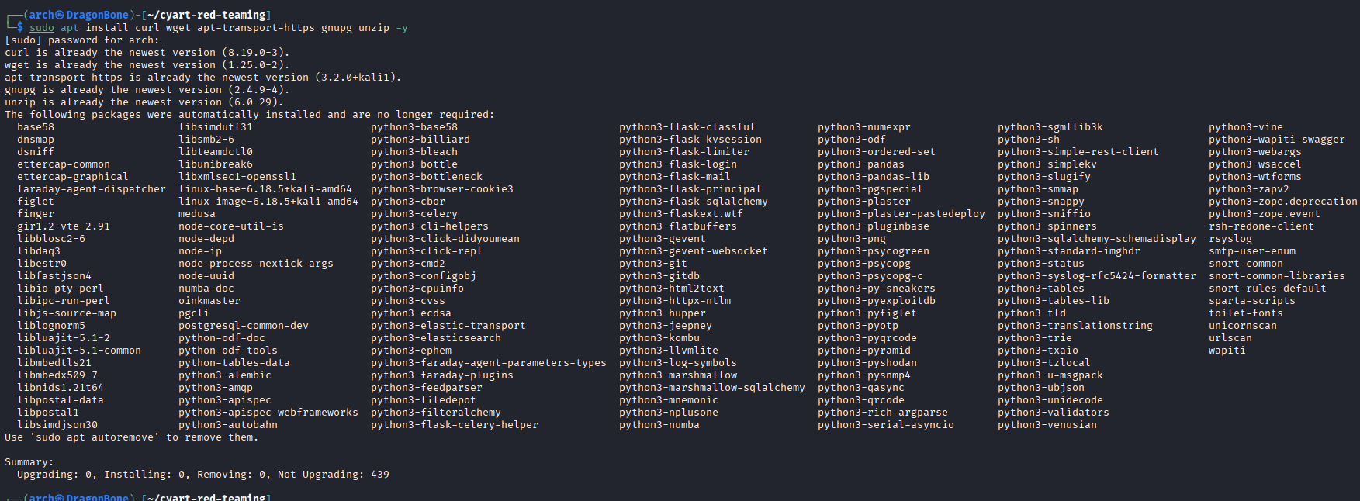

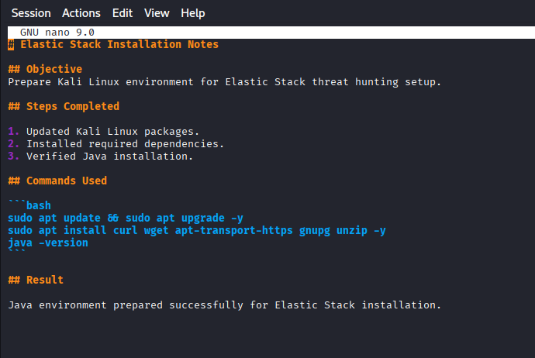

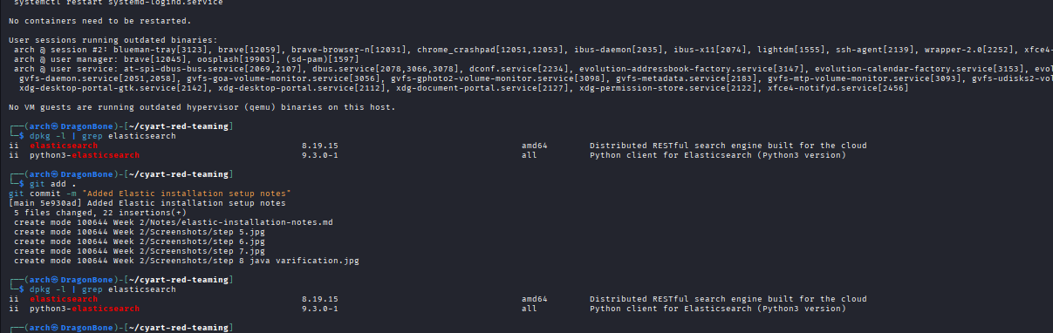

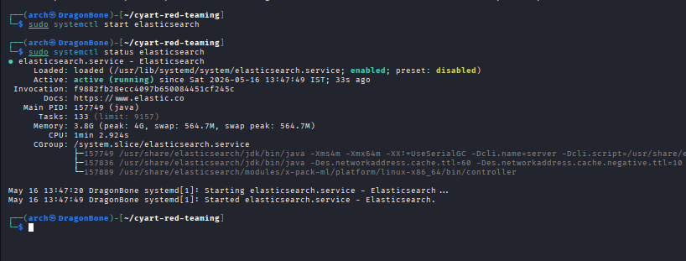

Update pass and log:
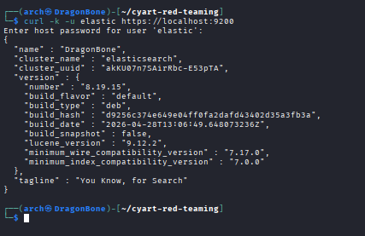

Update Notes File:
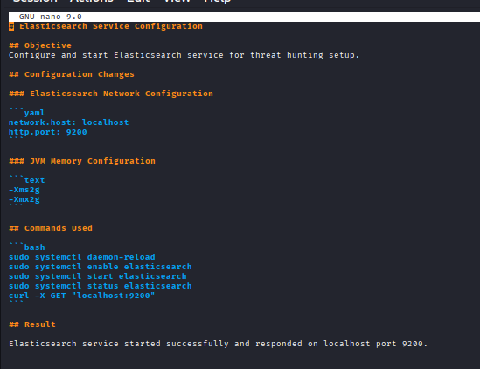

Commit cheneg :
git add .
git commit -m "Verified secure Elasticsearch connection"

Install Kibana:
sudo apt install kibana -y

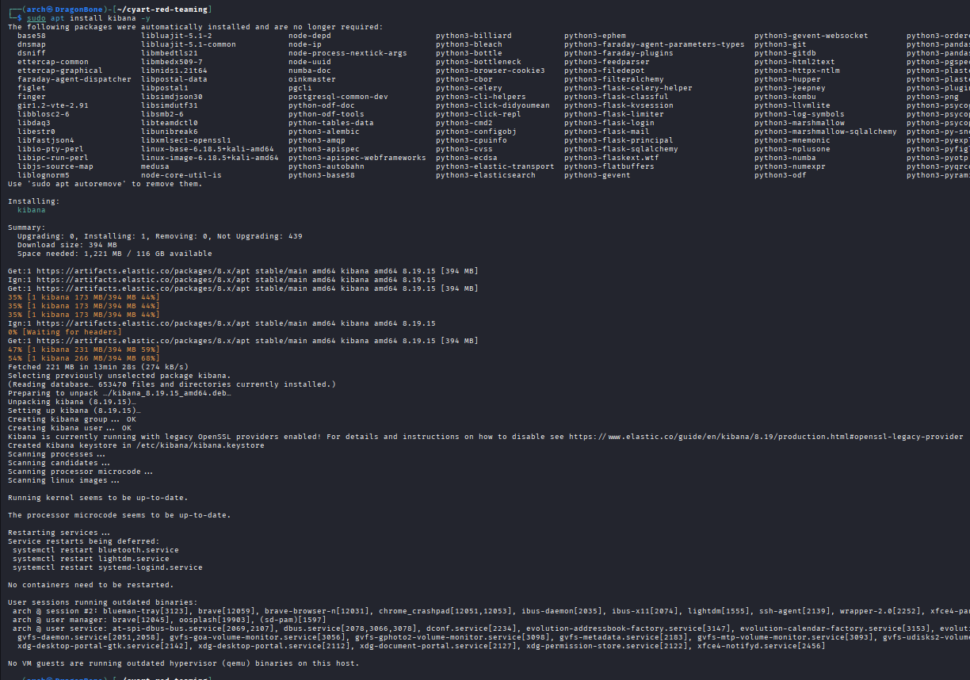

Kibana Logs:
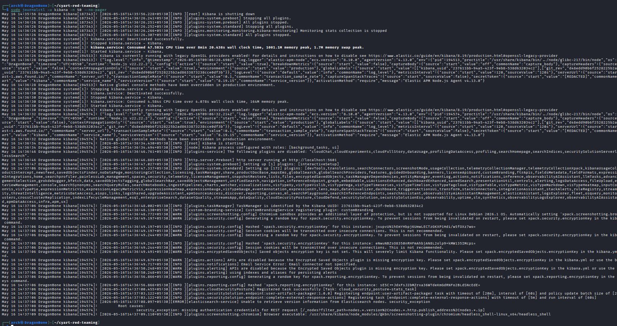

kibana status :
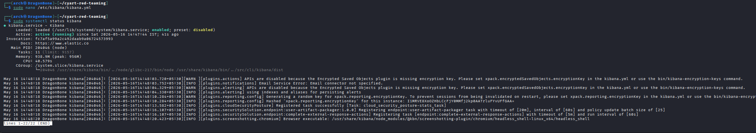

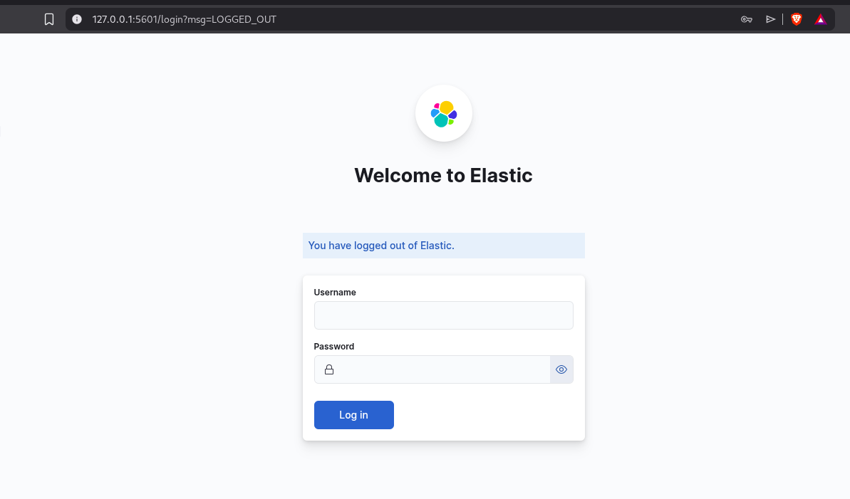

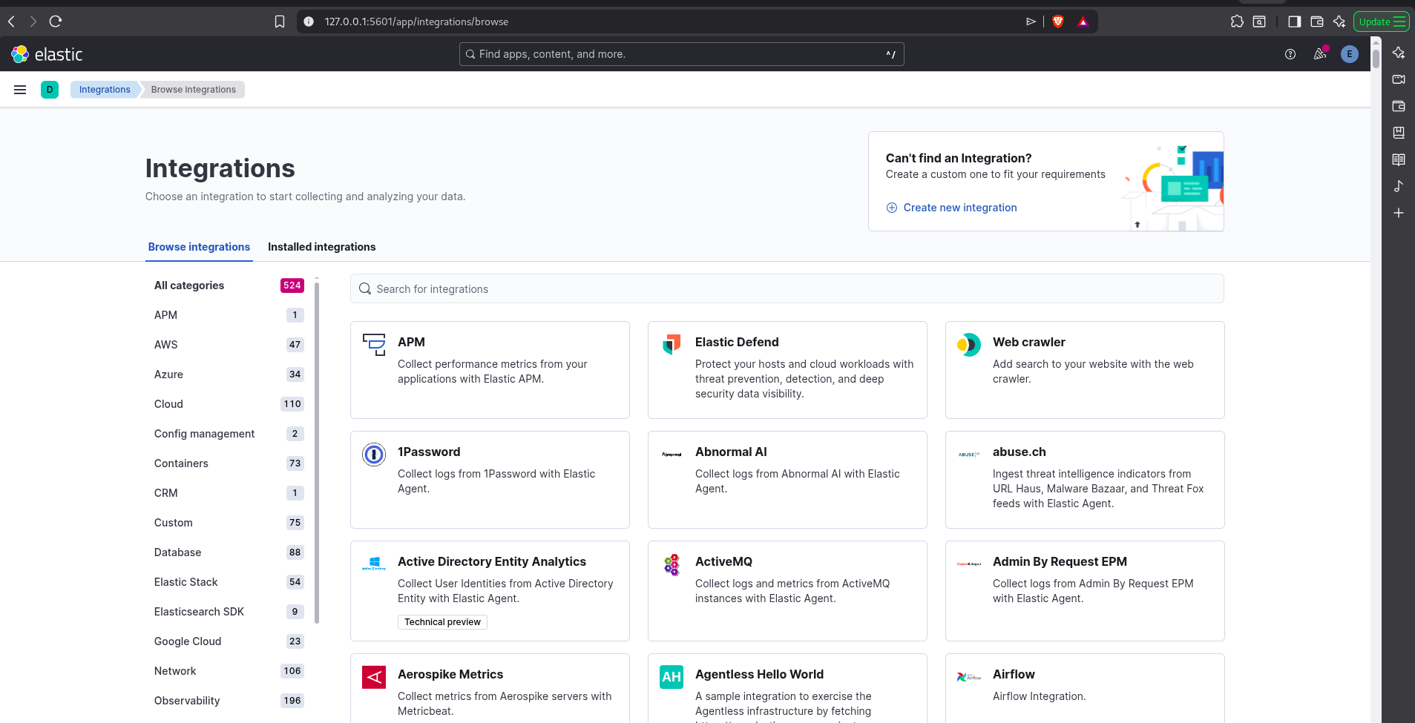

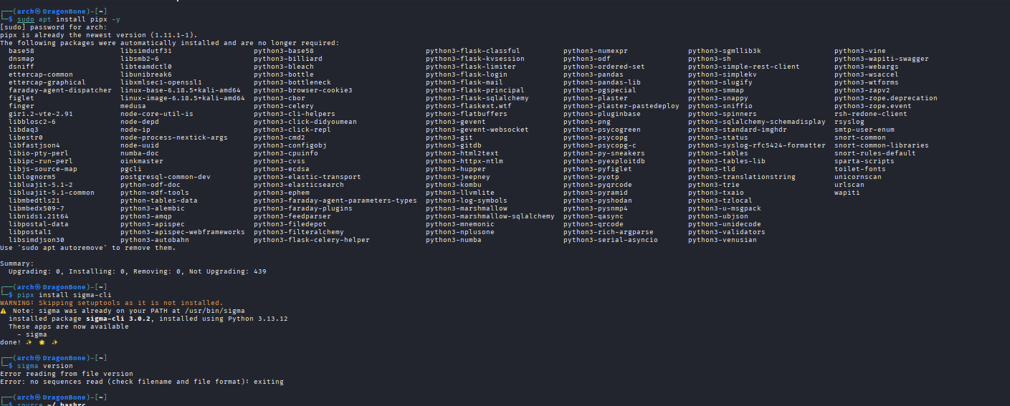

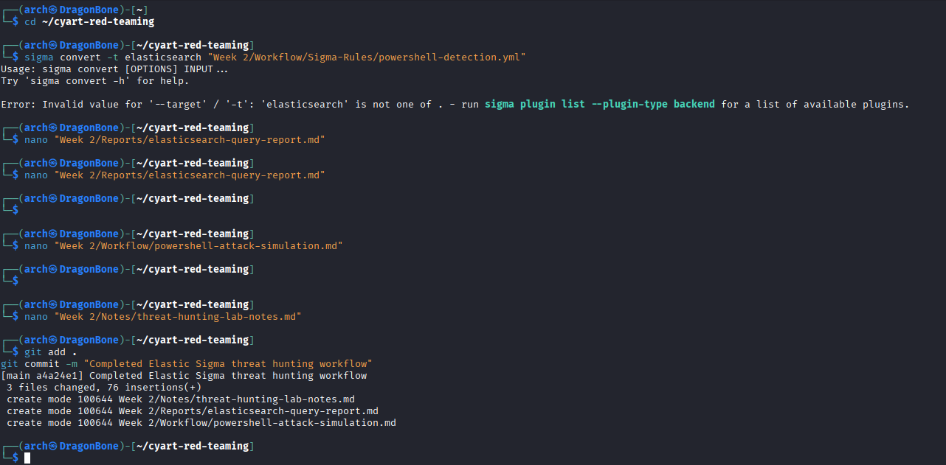

Install Filebeat
sudo apt install filebeat -y
filebeat version

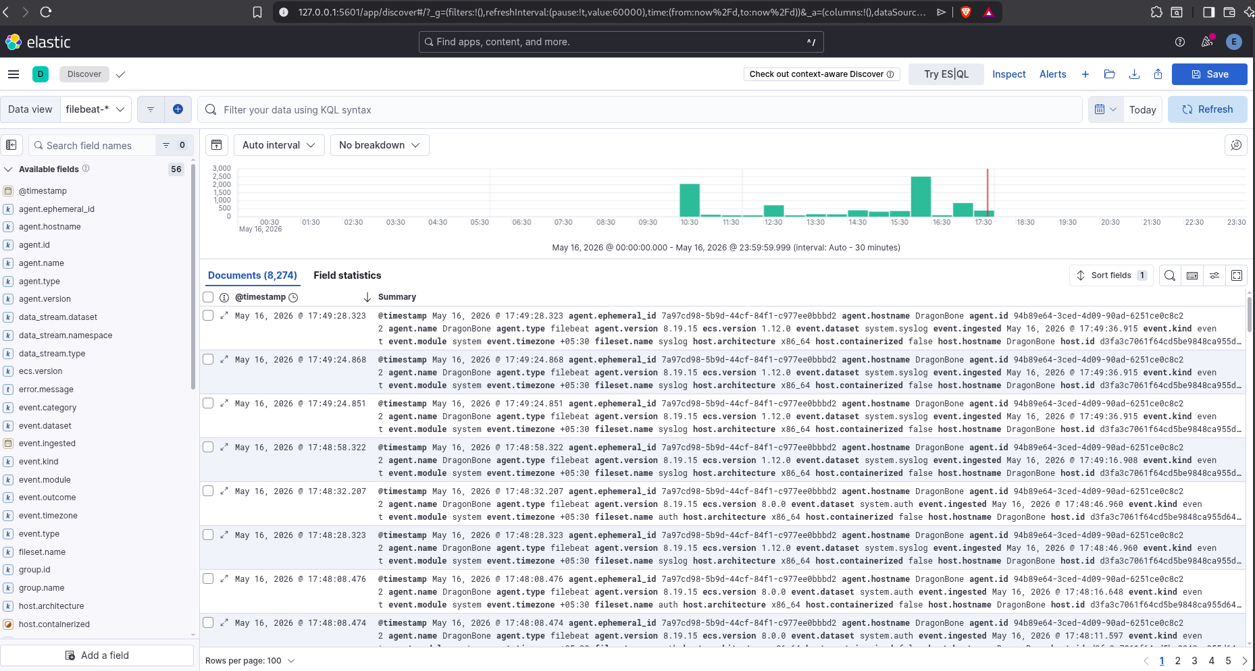

GENERATE SUSPICIOUS EVENTS:
echo "powershell.exe -enc suspiciouscommand" >> /tmp/powershell.log
echo "Failed password for root from 192.168.1.100" >> /var/log/auth.log
echo "nmap scan detected from attacker-host" >> /var/log/syslog

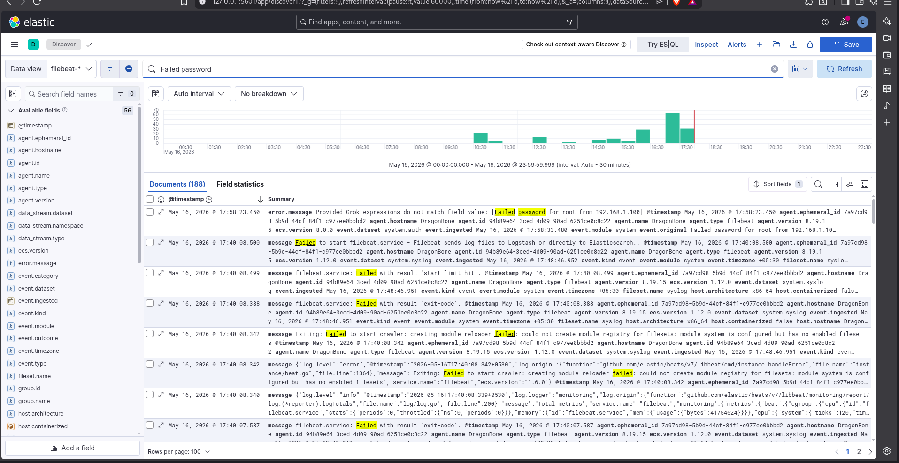

mkdir -p "Week 4"/{Detection-Rules,Dashboards,Screenshots,Reports,Workflow}

CREATE KIBANA ALERT RULE:

Kibana > Security → Alerts

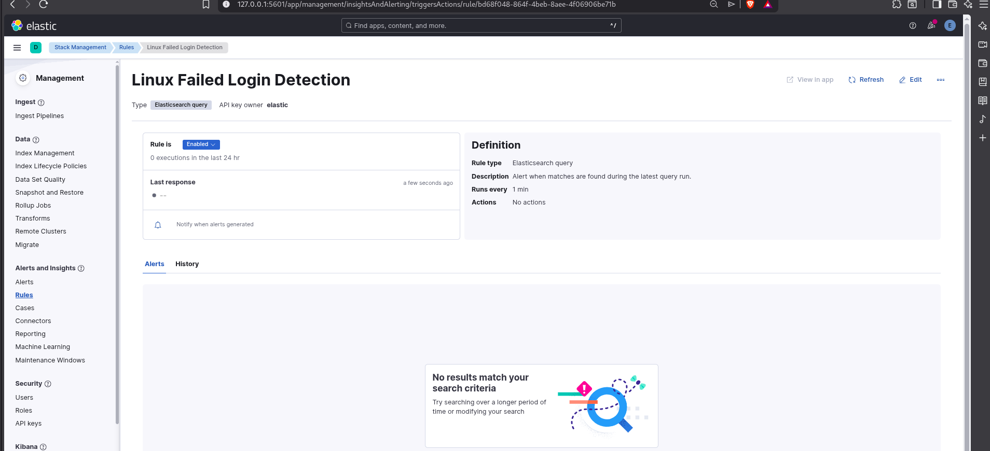

Dashboard Development
A SOC-style monitoring dashboard was created inside Kibana.

Dashboard Panels

Failed Login Timeline
- Authentication monitoring
- SSH brute-force visibility

Recon Activity Detection
- Nmap scan visualization
- Reconnaissance telemetry analysis

PowerShell Suspicious Activity
- Encoded PowerShell monitoring
- Script execution visibility

Reverse Shell Detection
- Command-and-control behavior monitoring
- Reverse shell telemetry detection

Malware Download Activity
- Suspicious curl/wget monitoring
- Payload retrieval detection

Alert Rule Configuration
Kibana alert rules were configured for:
- Failed login attempts
- PowerShell execution
- Nmap activity
- Reverse shell indicators
- Suspicious downloads
Alerting Features:
- 1-minute execution interval
- Threshold-based detection
- Elasticsearch query-based alerts

rule log detection :

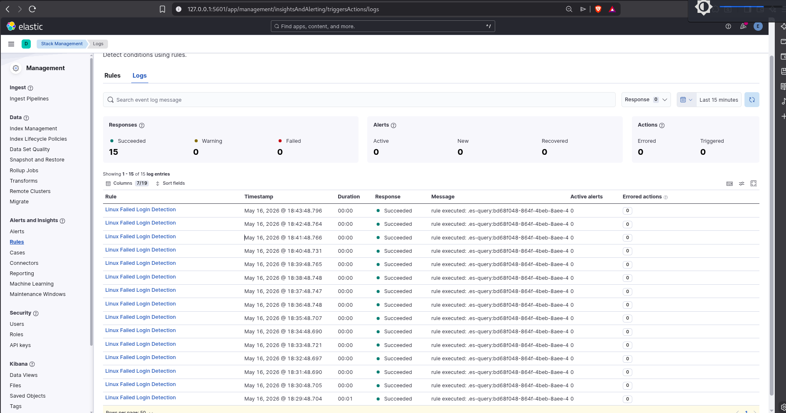

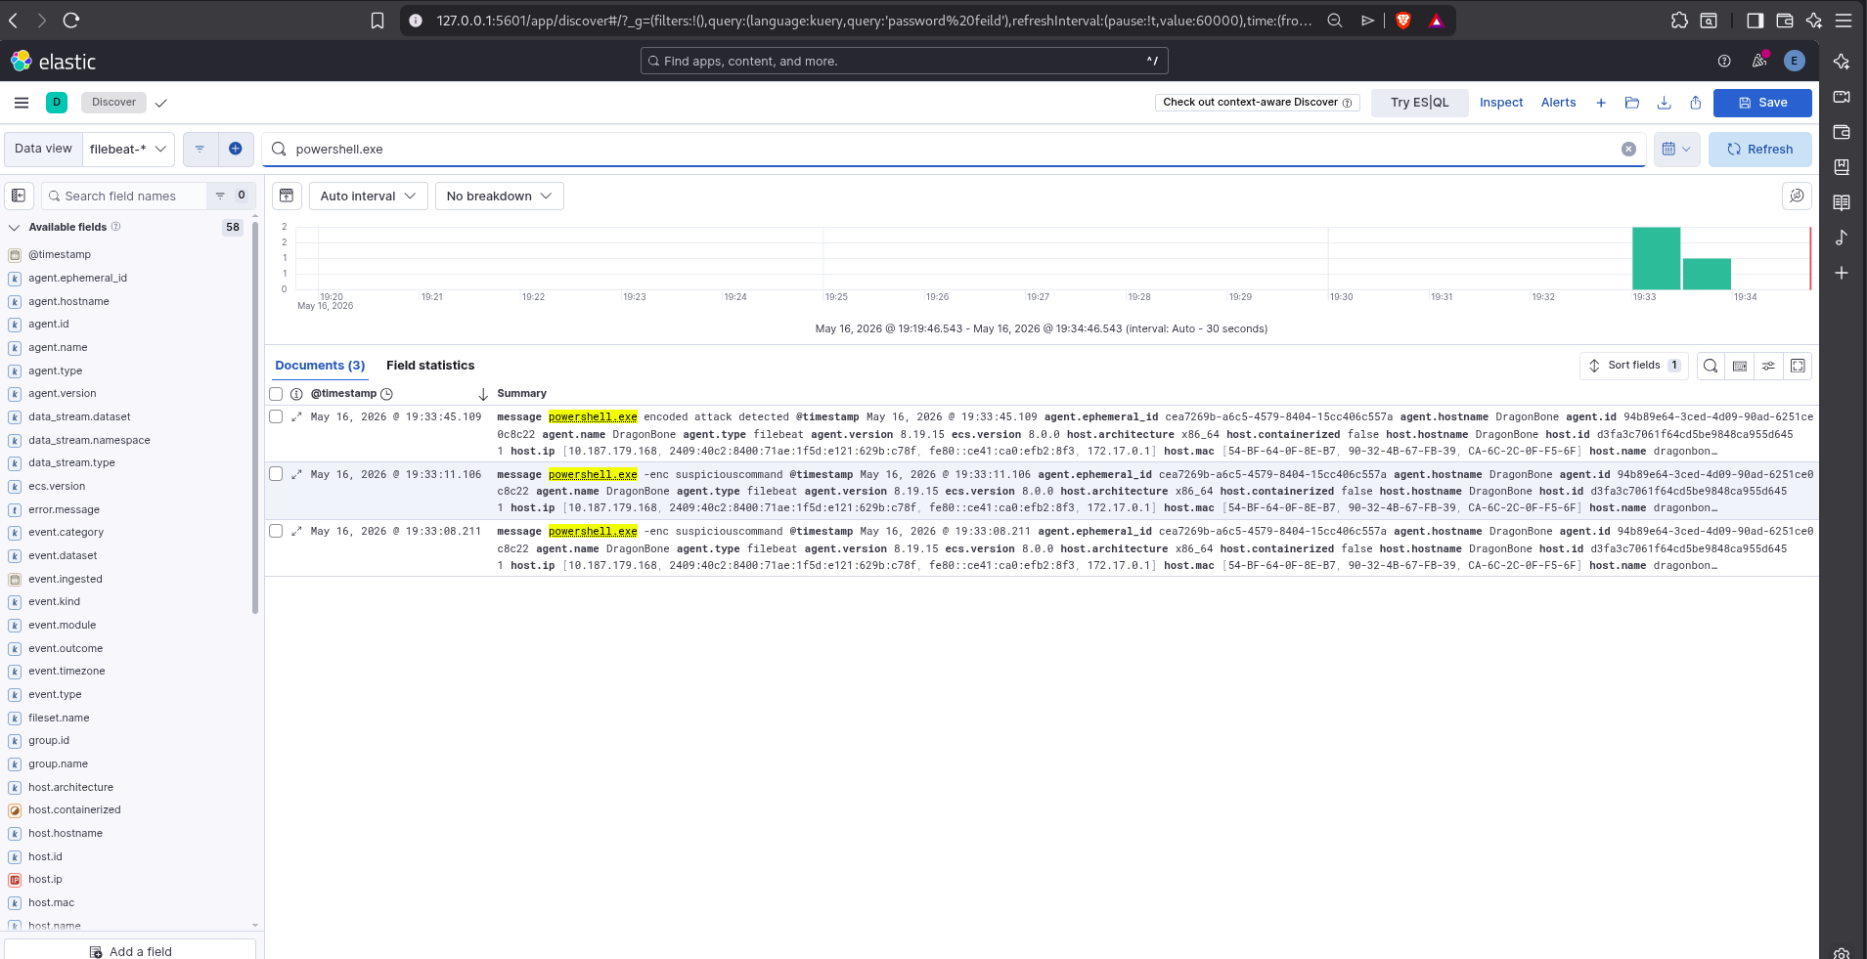

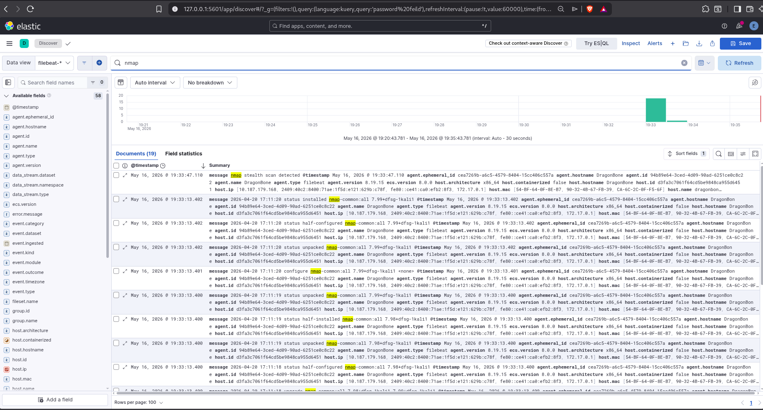

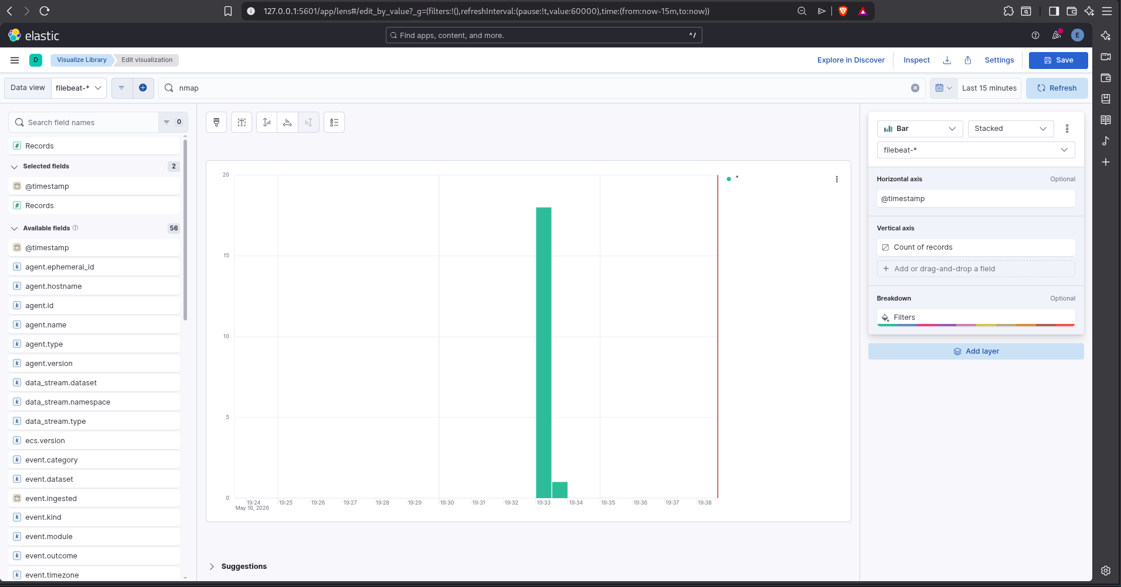

New Dashbord Created:

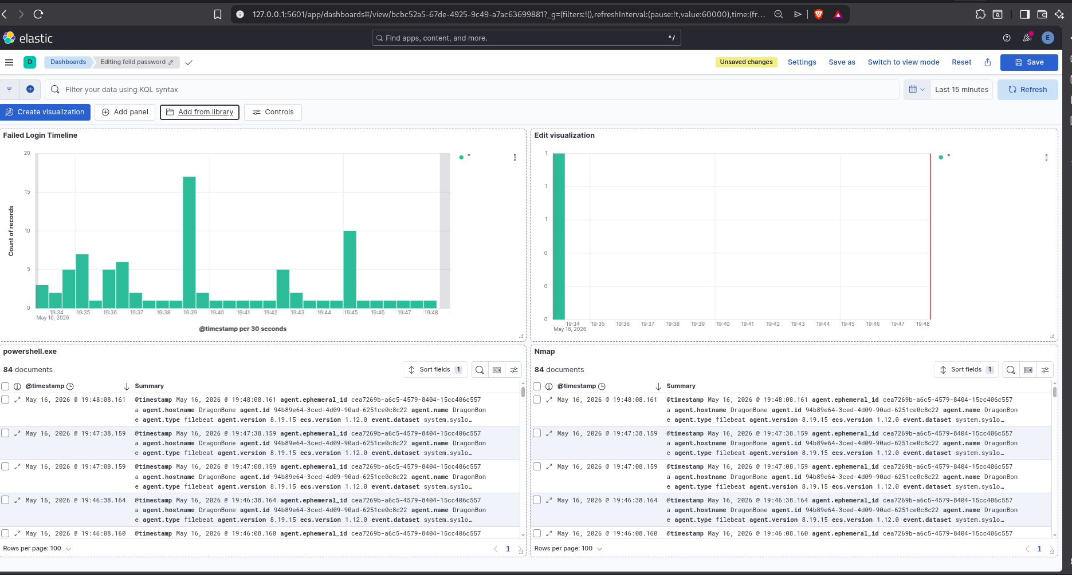

Kibana Threat Hunting

Searches Performed
Search Query | Detection Goal
Failed password | SSH brute-force attempts
nmap | Reconnaissance activity
powershell.exe | Script execution detection
curl | Suspicious downloads
wget | Malware retrieval
/dev/tcp/ | Reverse shell detection
chmod 777 | Privilege escalation

MITRE ATT&CK Mapping
Detection | MITRE Technique
Failed SSH Login | T1110 – Brute Force
Nmap Reconnaissance | T1595 – Active Scanning
PowerShell Execution | T1059.001 – PowerShell
Reverse Shell Activity | T1059 – Command and Scripting Interpreter
Curl/Wget Downloads | T1105 – Ingress Tool Transfer
User Creation | T1136 – Create Account
chmod 777 Activity | T1222 – File and Directory Permissions Modification

Challenges Faced
Several technical challenges were encountered during implementation:

YAML Configuration Errors
- Filebeat YAML formatting errors
Resolution:
- Corrected indentation and structure
- Validated configuration using:
sudo filebeat test config

Elasticsearch Authentication Issues
- Unauthorized authentication failures
Resolution:
- Correct Elasticsearch credentials added inside Filebeat configuration

Filebeat Data Ingestion Delays
- Logs not appearing in Kibana initially
Resolution:
- Expanded time range
- Verified Filebeat service status
- Validated index creation
- Restarted ingestion services

Kibana Alert Encryption Key Requirement
- Alerting required encryption key configuration
Resolution:
- Generated Kibana encryption keys
- Updated kibana.yml configuration

Outcomes Achieved
Successfully achieved:
- Functional SIEM deployment
- Real-time telemetry ingestion
- Threat hunting workflow implementation
- Detection engineering practice
- Dashboard visualization development
- SOC monitoring simulation
- Alert-based detection
- MITRE ATT&CK alignment
The project demonstrates foundational skills required for:
- SOC Analyst roles
- Threat Hunting roles
- Detection Engineering roles
- SIEM administration
- Security monitoring operations

Future Improvements
Potential future enhancements include:
- Wazuh integration
- Suricata IDS integration
- Endpoint telemetry collection
- Real malware sample analysis
- SOAR automation
- Email/Slack alert integration
- Threat intelligence feeds
- Advanced Sigma rule coverage
- Machine learning anomaly detection

Conclusion
This project successfully implemented an end-to-end SIEM threat hunting environment using the Elastic Stack ecosystem.
The environment demonstrated:
- Centralized log collection
- Real-time monitoring
- Threat telemetry analysis
- Detection engineering
- SOC dashboard creation
- Alert-based detection workflows
Through practical attack simulation and telemetry analysis, the project provided hands-on experience with modern cybersecurity monitoring operations and established a strong foundation in SIEM-based threat hunting.
The completed implementation reflects real-world SOC concepts and demonstrates operational understanding of log management, threat detection, and security analytics workflows.

GitHub Repository
Repository Name:
cyart-red-teaming
https://github.com/SidVela/cyart-red-teaming
Project Includes:
- Workflow documentation
- Sigma rules
- Screenshots
- Detection reports
- Dashboard visuals
- Threat hunting notes
- Configuration references

